10.87: The intial angular momentum of the bullet is 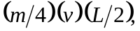and the final moment of intertia of the rod and bullet is 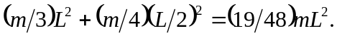 Setting the initial angular moment equal to 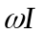and solving forgives 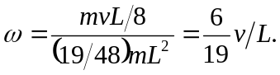
b) 